WINDOWS SOC DETECTION REPORT

Suspicious & Encoded PowerShell

Detections | 002 / 003
Wazuh rules | 100300 / 100301/100302
Endpoint | window10 / 192.168.34.148
Status | Lab detection validation
Analyst | Vipin Kumar

1. Executive Summary
Wazuh detected PowerShell process-creation activity on Windows endpoint window10 (192.168.34.148). Rule 100300 generated Level 10 alerts for suspicious characteristics, including hidden-window execution. Rule 100301 generated a Level 12 alert for an encoded command. The supplied encoded payload decodes to a harmless Write-Host test string. These results demonstrate detection behavior in a lab, not a confirmed compromise.

2. Environment
Wazuh manager: vm1
Windows agent: window10, agent ID 002, IP 192.168.34.148
Windows computer in Sysmon: DESKTOP-0P32A1N
Telemetry: Microsoft-Windows-Sysmon/Operational, Event ID 1 (Process Create)
Input location: EventChannel

3. Detection 003 — Suspicious PowerShell
Rule 100300; Level 10; groups sysmon, powershell, suspicious_powershell; MITRE T1059.001. Observed command: powershell.exe -windowstyle hidden -command "Write-Host test". User: DESKTOP-0P32A1N\vipin. PID 13156; parent powershell.exe PID 10780. Event time 2026-10-17 07:25:56.216 UTC. The hidden-window flag is suspicious, but the command itself appears test-oriented. Treat as a detection test unless corroborating evidence indicates malicious activity.

4. Detection 004 — Encoded PowerShell
Rule 100301; Level 12; groups sysmon, powershell, suspicious_powershell, encoded_command; MITRE T1059.001 and T1027. Observed command uses -enc with a Base64 argument. User: DESKTOP-0P32A1N\vipin. PID 8008; parent powershell.exe PID 1696. Event time 2026-10-17 07:30:58.306 UTC. The decoded UTF-16LE content is: Write-Host 'This is an encoded test command'. This is a benign test payload; encoded execution alone is not proof of malware.

5. Related Detection — Office spawning PowerShell
The combined Wazuh search also showed rule 100302, Level 13, for an Office application at C:\FakeOffice\Office16\WINWORD.EXE spawning PowerShell. Office-to-script process chains deserve review, but the supplied evidence does not prove a malicious document or successful payload execution. Verify whether this was deliberately generated in the lab.

6. Evidence Summary
Screenshots show 11 combined results for rules 100302 OR 100301; six events for rule 100300; and visible events for encoded PowerShell and Office-to-PowerShell behavior. These counts reflect the selected dashboard range and are not guaranteed unique execution counts. Deduplicate with process GUID, event record ID, host, and time.

7. MITRE ATT&CK
T1059.001 — PowerShell (Execution): applicable to PowerShell execution behavior. T1027 — Obfuscated Files or Information (Defense Evasion): mapped by the encoded PowerShell rule. These mappings describe detection context, not proof of malicious intent.

8. Findings & Verdict
Confirmed: Sysmon process-creation events were collected and Wazuh rules 100300 and 100301 generated alerts. The encoded test payload is benign-looking. Not established: compromise, persistence, data theft, or successful malicious download/execute activity. Verdict: Lab detection validation / suspicious behavior requiring context; no compromise confirmed.

9. Recommended Response
1. Confirm all commands were deliberately executed as lab tests. 2. Correlate parent/child processes and process GUIDs. 3. Review PowerShell Operational events 4103/4104 if logging is enabled. 4. Inspect network and file activity around suspicious commands. 5. Investigate rule 100302 separately. 6. Test benign baseline commands to assess false positives. 7. Tune logic to use multiple indicators and context rather than alerting on every PowerShell launch.

10. Limitations
The exact custom rule XML was not supplied, so this report records observed alert behavior but does not validate every rule condition. Screenshots and alert JSON do not prove whether a remote command completed or whether a file was downloaded. Additional endpoint telemetry is needed for those conclusions.

11. Conclusion
The lab successfully produced Wazuh alerts for suspicious PowerShell characteristics and encoded PowerShell execution. The encoded command decodes to a test message, so it should not be reported as malware. Keep the results as a detection-engineering demonstration, and distinguish test activity from confirmed malicious behavior.

Appendix A — Evidence Screenshots

E01-suspicious-powershell-dashboard.png
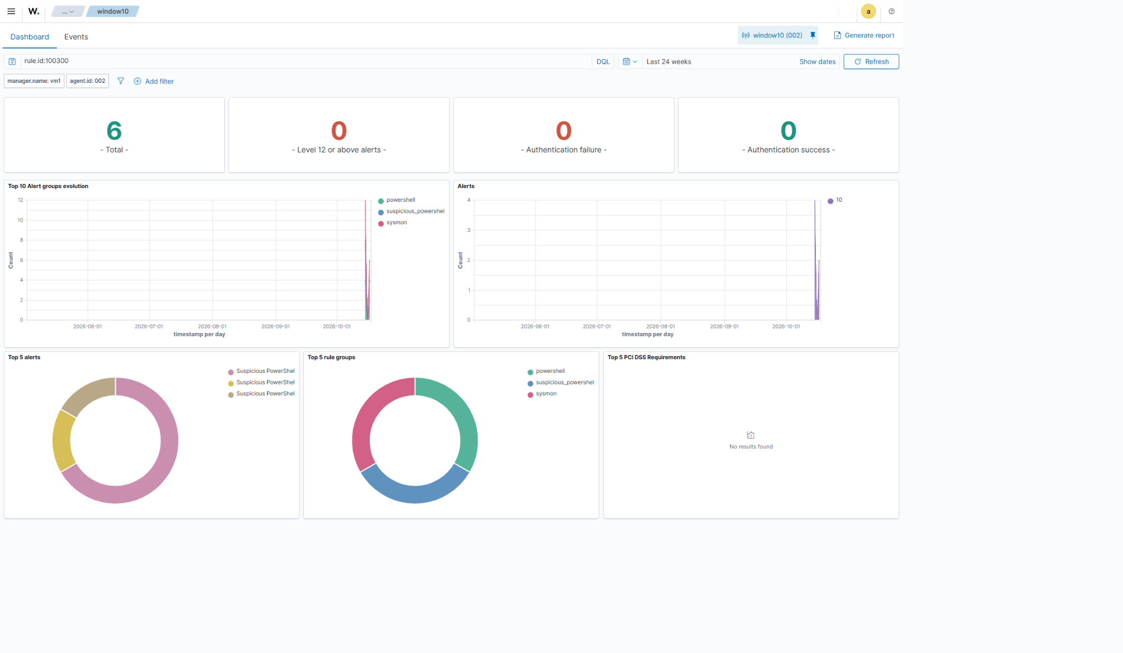

E02-suspicious-powershell-alerts.png
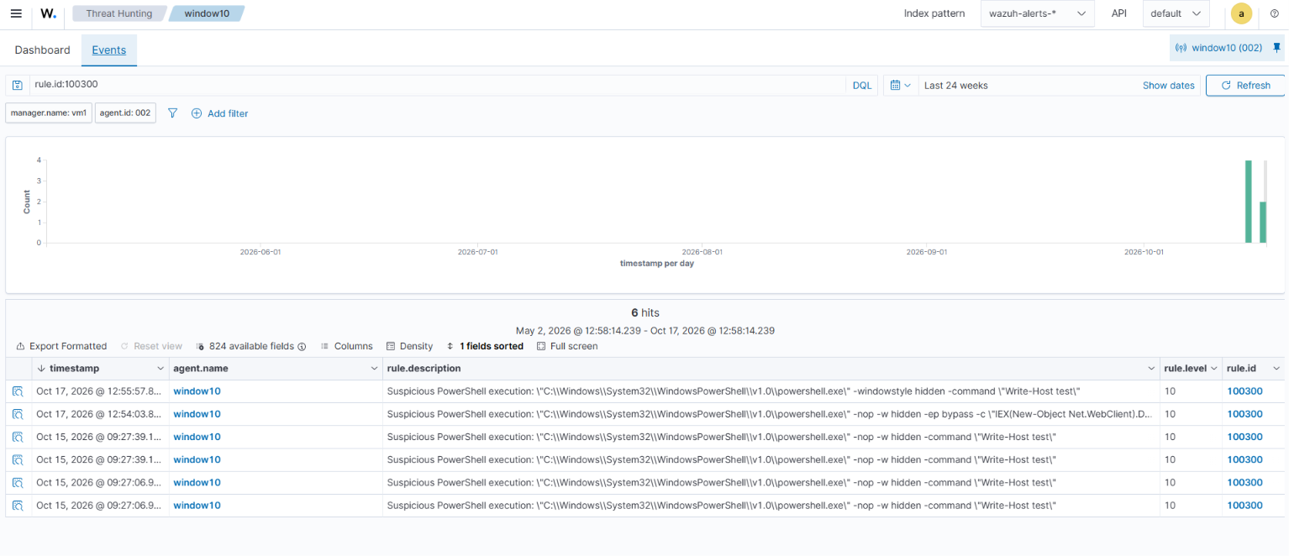

E03-encoded-powershell-alert.png
